HILL LANE SURGERY Newsletter
August 2022
Welcome to August Newsletter. Wow what a hot summer we are having so far. Please stay safe, drink plenty of water and stay in on extremely hot days.  All updates of extra information from the surgery are added to our ‘Hill Lane Surgery’ Facebook page. Come join our page and get regular updates. |  | We are always here to help, and offer ‘face to face’ appointments as well as telephone consultations, just let us know which you would prefer when booking with our reception team. Any Covid queries call 119 or visit the NHS website.  Kind regards Laura Practice Administrator | E-Consults  We have E-Consults on our website which mean if you complete an E-Consult we may be able to assist you rather than calling the surgery.  NHS APP  With the NHS App you can book and cancel appointments, order prescriptions, and view your medical history and immunisations.  You can also get access to your Covid-19 pass.
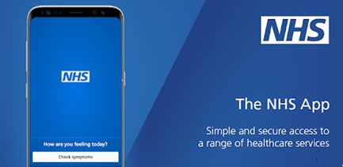

NHS Community Pharmacist Consultation Service (CPCS).
This is a referral service for a variety of minor ailments that will not only free up GP time but also allow patients to be dealt with more quickly within their local area by another qualified NHS professional. This service deals with bites/stings, colds, congestion, ear problems, eye issues, gastric/bowel problems, gynaecological issues/thrush, certain types of pain, skin problems, mouth/throat issues and swelling. A patient will be triaged before being referred to this service to see if suitable. If they are then they will be referred to their usual pharmacy (or another local one if theirs isn’t available) and they will be sent a text or given the details over the phone. The Pharmacist will then contact the patient and give them a time to come to the Pharmacy to have a consultation with the Pharmacist. This will usually be the same working day.

Patients can be assured that they will be seeing the most appropriate professional to deal with their issue.

Steps 2 wellbeing
Do you suffer from any of the following?
Anxiety
Depression
Stress
Social anxiety
Specific phobias
Panic
Post-Traumatic Stress Disorder (PTSD)
Obsessive Compulsive Disorder
Is life sometime difficult because of how you feel? Are you or someone you care about feeling scared, anxious, low, or stressed? Come and have a chat with your GP OR you can even self-refer! Why not go to their website and find out how? www.steps 2wellbeing.co.uk
 |  | 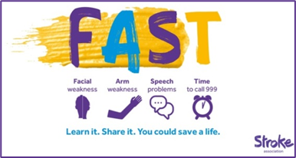
https://www.jostrust.org.uk/about-us?gclid=CjwKCAiAhfzSBRBTEiwAN-ysWIVlPzyexe1oe2o5AZ3ZG0S500W5xKV9ymS5hBKyq90IyKuUZhqHARoCWPkQAvD_BwE  Please call the surgery to book an appointment if your smear is due. Please click on the link above for more information, and answers to lots of questions about cervical screening.  "A smear test lasts 5 minutes. The Impact of cervical cancer lasts a lifetime"  Attend your smear test. |  | The Stroke Association are the UK’s leading charity dedicated to conquering strokes. For more information visit: www.stroke.org.uk

